**Hello Fellow Miata Enthusiast !**

Spring has not been that friendly for getting things underway, but the temps are rising and the sun is trying to shine through. We’ll be reuniting with our Miata friends before you know it. I hope this newsletter finds you having had a good off-season. By the early counts, it looks like we have some new members coming on board this year and we look forward to meeting them.

For those of you that have not yet renewed, joining and/or renewing for the year remains simple, and the new website now offers an online mechanism to pay. Yearly membership remains at $25 /year (April thru March). Recall that you are registering your Miata, so the $25 covers the Pilot and Co-Pilot. VMC Name tags are available for purchase on the application form and would be a one-time fee. The Application can be filled in online or mailed to Dan (it’s attached here for ease if you desire the mailing option). To access the members only section of the website you will need to establish credentials. Click on Join Us, provide a User Name and Password you desire and submit it. You will receive a confirming email from WordPress showing that it has been received. Dan or Donna will then approve it and you will get a notification accordingly.





**Notes from the rearview mirror ~ the year in review !**

Last year was my first full year with the VMC and I got to see first-hand the variety of things the club had to offer. During the year we had a lot of folks step up to plan and lead Wednesday night rides, day trips, weekend and week long getaways. With folks stepping up, it allowed some of the other long time members that had been running the club to sit back, focus on the pedal & stick shift and enjoy the ride..

The Wednesday night rides took us North, South, East and West and we even took a Ferry ride to Essex NY.. who knows where we’ll end up this year – have a suggestion – pass it to us..

Dan Gaffney put together a great itinerary for Nova Scotia. 5 cars participated in this week long get away enjoying a great mix of scenery, history and culture of this Canadian Paradise. Spending the week together formed some great new friendships and we all appreciated all the time and effort Dan put into planning this trip.

Late July featured a day trip to Magog Canada visiting lavender farms and making a nice loop back to the states with Dan again in the lead.

Tom Brown led the way to Rangeley, Maine for Operation Bullwinkle VII. The elusive moose is still out there to be seen, but we had great time as the club took over the Country Club Inn. While hanging out in a common viewing area, we got a little nervous when Border Patrol radioed for backup. When backup arrived to see our group of cars, we quickly learned that his partner was a Miata Enthusiast, and thought this might make his night ! The smile on his face was incredible and boy oh boy did he know his Miatas! Below is the group he arrived to.

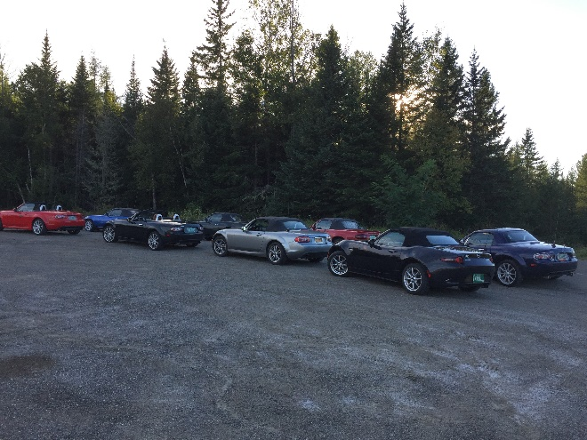

Pat and Jeanne Kennedy decided to steer the group to the South. Destination was Plymouth VT home to the Calvin Coolidge Historic Site. It was interesting to learn about our 30th President within the onsite museum and see his whole hometown preserved being able to go into his house, school, general store and church.

Bruce and Diane Clemens hosted a NEK Brew tour finding a nice balance of food and drink along the way. This trip ventured to St. Albans, Newport, Hyde Park with a dinner destination in Morrisville. Although it was a cooler fall day, the group forged onward and took one for the team.

Monica and Mark hosted the annual Holiday party which was well attended and had plenty of food to go around. This event includes a Yankee swap and has become the forum where the “coveted” VMC trophy is presented to the next recipient. This is such a “lovely” trophy, it’s really the kind of thing you hope somebody else will be honored with! History shows that this started back in 2004 at the annual holiday party at Pam Gosselins home in Waterbury Center. Kinne Aja had it in his junk pile and repurposed it into the club. At this time, the VMC was known as the Green Mountain Miata Club. We compiled it back to 2013 where Tom Brown presented it to Marianne Steen. This was also the year that the Vermont Miata Club was renamed from the GMMC.

Although Donna and I missed the Holiday gathering, somehow this “treasure” made it to our household as the 2018 recipients ! We are told we “earned” it due to helping the club out with the website, social media presence and the like. As directed, this sits on the hutch in our dining room seeing how it is expected to be displayed in a prominent place for a year !

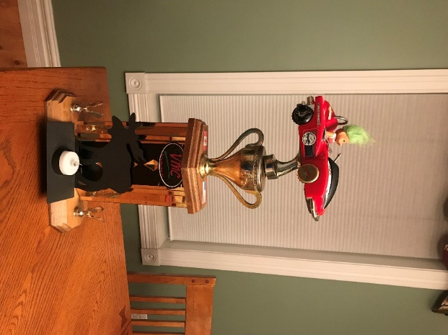

Below are the known recipients. The trophy seems to also take on a new look each year, as it gets customized before the handoff.

|  |  |
| --- | --- |
| 2012 | Tom Brown |
| 2013 | Maryn Steen |
| 2014 | Dan & Donna Gaffney |
| 2015 | Ed & Jane Vizvarie |
| 2016 | Tom & Betty LaPierre |
| 2017 | Dan & Donna Gaffney |
| 2018 | David & Donna Rouleau |

**Notes looking through the windshield ~ what’s ahead of us !**

The weekly Wednesday night Ride and Dines will be starting up soon, as the temperatures rise and drier weather allows us to get the tops down. Starting point will remain at the back parking lot of Staples in So. Burlington. Plan to arrive for 5:45, we’ll get a head count, arrange a destination and depart at 6:00. These rides normally meander around back roads and end at a restaurant, creamy stand etc.. based on the group’s desire. Last year we announced the Wednesday destination earlier in the week and this seemed to work for people allowing them to opt in or out. Last year we coordinated a few where we “picked” members up on the way to our destination, eliminating them from back tracking. We also have some members coming a good distance, this seemed to help them with planning their return trip after supper. We hope to kick off the season next Wed May 29th.

Just a reminder that when we roll, a bunch of us communicate using CB radios to keep the pack together, relay info or for some good ol’ banter. It is helpful to have radios for the Lead, Sweep and middle of the pack. If you are looking to equip your car, the Cobra 75 is the recommended compact unit. We operate on CB Channel 5 or 27.015 on a NASCAR type scanner if you want to just listen in.

There has been talk about having a summer picnic and coordinating this with a Wednesday Ride. One or our members has thrown out an offer to host one at their camp. Stay tuned for details once a date is selected.

**Operation Bullwinkle Vlll**

**Dates: October 5th and 6th 2019**

**Where: Country Club Inn, Rangeley, Maine (207) 864-3831**

<http://countryclubinnrangeley.com/>

**Room and breakfast for two:**

**$149 for Oct. 5th, $139 for Oct 6th**

**Room and breakfast for one:**

**$119 for Oct 5th, $109 for Oct 6th**

**Mark your calendars now and make your reservation before July 4th.**

This traditional weekend getaway can be done as a 1 or 2 night stay. It’s a quaint Inn where we enjoy dinner and breakfast as a group and then have the lodge to ourselves to enjoy good company, drinks, games and laughter on Saturday night. After arriving, there is free time to explore Rangeley and we ride to a viewing area where moose are known to be (except when we are there 😉 ) before we had back for supper Saturday night. Scenic drive is usually in the mix again on Sunday.

Tom is hoping to allocate every room with Miata Owners. We’ve had some emails sent out in the off season to our group, and Tom has now extended invites to the Hudson Valley Miata Club, the Quebec City Miata Club and the Trillium Miata Club which have already had some members book rooms. Please sign up ASAP to ensure availability. Contact Tom Brown for more details (802) 233-9060 [tbrown1948@gmail.com](mailto:tbrown1948@gmail.com)

Below is Tom trying to lure Bullwinkle in, the Sunday a.m. group ride attendees, view of Lake Rangeley and morning coffee on the deck !

